Lab 2: Creating Lab Environment:

Task 1: Lab Environment Preparation
- Install VMware Workstation:
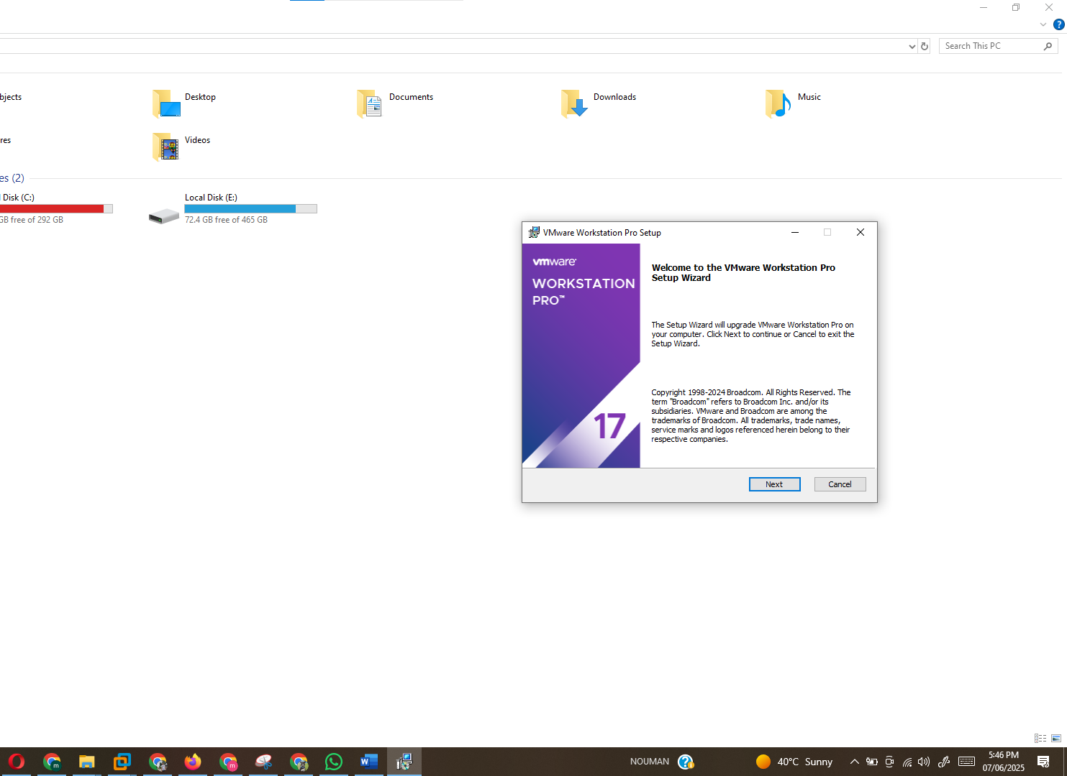
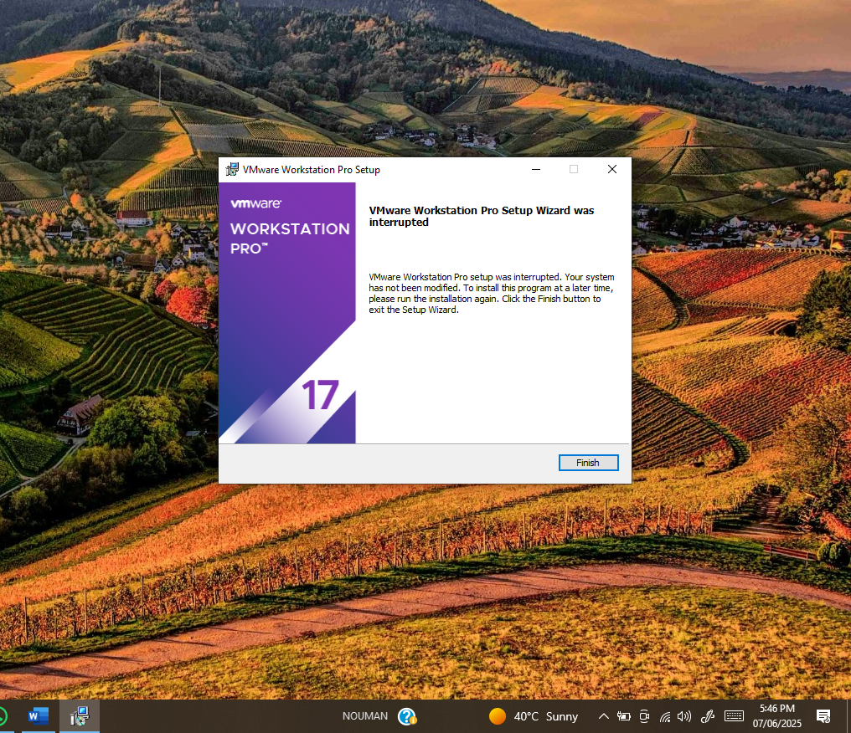
- Install Windows 10 in VMware:
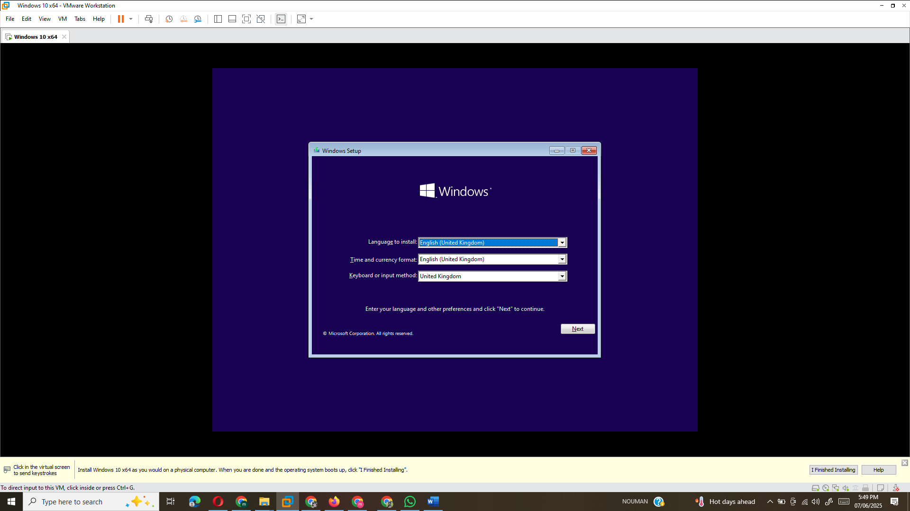
- Install Kali Linux in VMware:
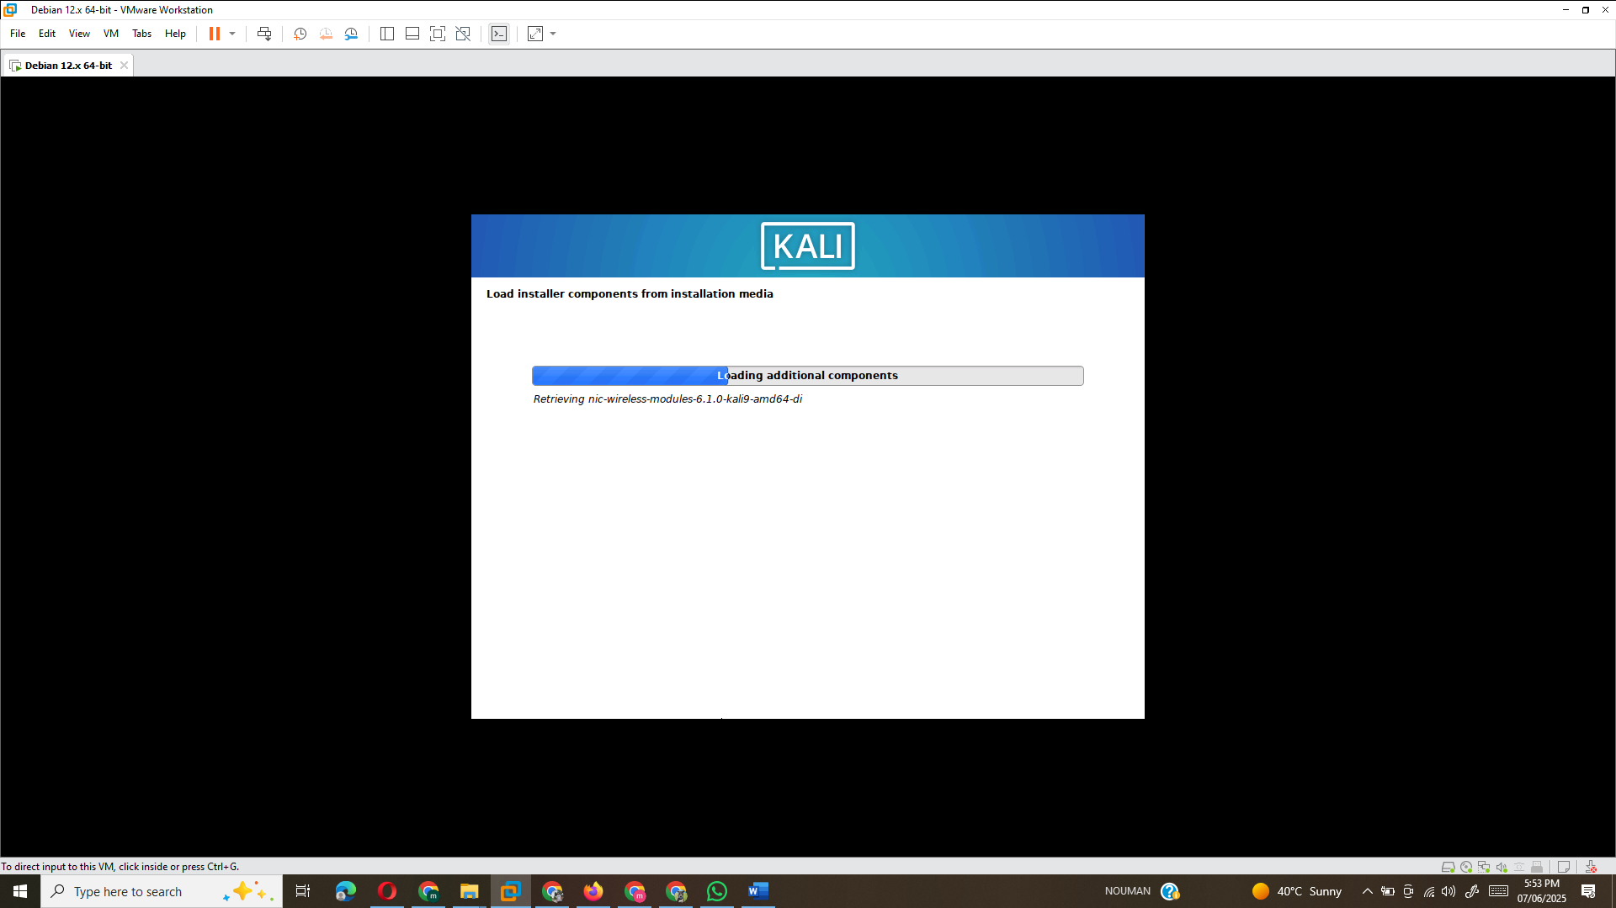
- Install Ubuntu Desktop in VMware:

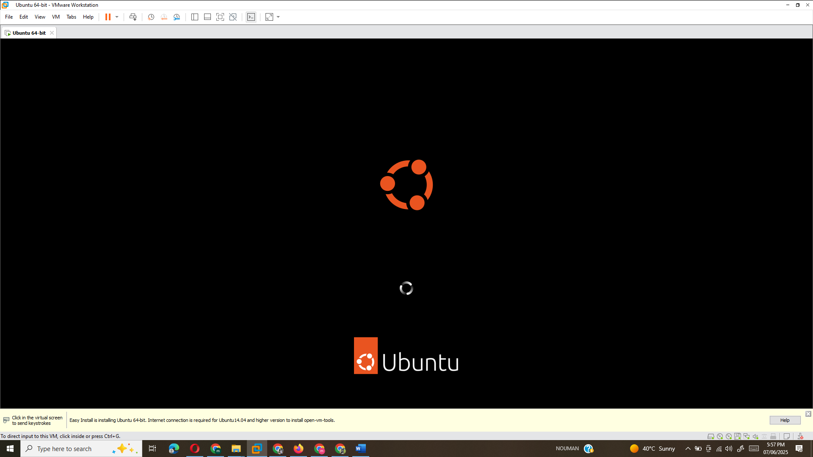

Task 2: Questions Related to Cyber Threats
- Highlight the Most Common Cyber Threats:
  - Some of the most common cyber threats today include:
    - Phishing: Fraudulent attempts to obtain sensitive information by impersonating a trustworthy entity.
    - Ransomware: Malicious software that encrypts a user's files and demands a ransom for the decryption key.
    - Malware: Software designed to harm or exploit any device, service, or network.
    - DDoS (Distributed Denial of Service): A cyber attack in which the perpetrator uses multiple systems to flood a network, making it unavailable to users.
    - SQL Injection: An attack that allows attackers to execute malicious SQL statements to access the database of an application.
- How These Threats Are Utilized in Attacks:
  - Phishing: Attackers send fake emails or messages to trick users into revealing personal information or clicking on malicious links.
  - Ransomware: Typically spread via email attachments or through exploit kits, encrypting the victim's files and demanding a ransom.
  - Malware: Delivered through infected downloads, websites, or attachments, malware can steal data, damage systems, or provide remote access to attackers.
  - DDoS: Attackers use botnets to send high volumes of traffic to overwhelm a target system, rendering it inaccessible to legitimate users.
  - SQL Injection: Attackers inject malicious SQL queries into input fields, enabling them to access and manipulate the backend database.
- Real-World Examples of Cyber Threats Impacting Businesses:
  - Phishing: Recent phishing campaigns have targeted employees in the banking sector, leading to significant data breaches.
  - Ransomware: In 2020, the Ragnar Locker ransomware attacked multiple companies, including energy providers, encrypting sensitive data and demanding a ransom.
  - Malware: The NotPetya malware attack in 2017 hit multinational companies and caused billions in damages by spreading through networks.
  - DDoS: Cloudflare reported an increase in DDoS attacks during the COVID-19 pandemic, where attackers targeted remote work infrastructure.
  - SQL Injection: The Heartland Payment Systems breach in 2009 occurred due to an SQL injection vulnerability, exposing millions of credit card details.

References
- Kearns, D., O'Gorman, J., & Aharoni, M. (2019). The Principles of Computer Security: CompTIA Security+ and Beyond (5th ed.). McGraw-Hill Education.
- Zimmermann, P. (1999). Why I Wrote PGP. Retrieved from https://www.philzimmermann.com/EN/essays/WhyIWrotePGP.html
- Stallings, W. (2019). Computer Security: Principles and Practice (6th ed.). Pearson.
- CompTIA. (2020). CompTIA Security+ SY0-601 Exam Objectives. CompTIA. Retrieved from https://www.comptia.org

